NAME – Suraj Kumar Jaiswal

Phase 1 – Virtual Key for Your Repositories Project

**Creating a Story**:

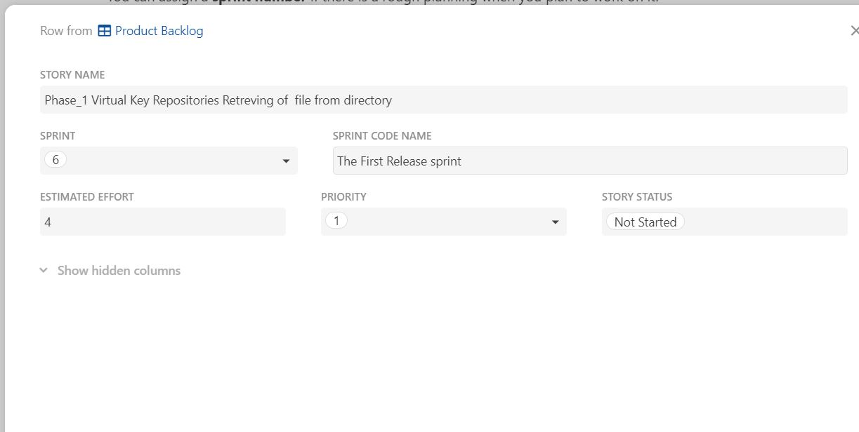

**Creation of Task** :

